Paris Travel Itinerary

ARRIVAL INFORMATION
London St Pancras to Paris Gare Du Nord
Carriage 17, Seat 74
Saturday, 13th Sept 2008
Depart London at 20:05 and arrive in Paris at 23:20

DEPARTURE INFORMATION
Paris Gare Du Nord to London St Pancras
Carriage 18, Seat 24
Wednesday, 17th Sept 2008
Depart Paris at 12:13 and arrive in London at 13:28

Remember to check in 45 minutes beforehand.

ELECTRICAL INFORMATION
Power outlets in France
Two round pins
Bring an adapter just in case.

PACKING LIST

- Comfy shoes for lots of walking we’re gonna do
- Warm clothing for cold nights
- Sunglasses
- Umbrella or Raincoat (it’s rainy season in Paris)
- Camera
- Medication (if you have any)
- iPod with audioguides from http://www.ricksteves.com/news/travelnews/0602/france_downloads.htm
- Extra bag to pack your shopping
- Guide book or phrasebook to pass time while waiting in line
- Printed Itineraries for Eurostar, Paris Pass and Hotels
- Passport

ROUGH ITINERARY

Day One – Sunday, 14 September

Most shops are closed on Sunday, so we’ll focus on the sights and museums.

9:30am – 11am, Musée d’Orsay
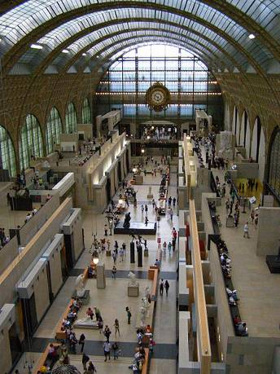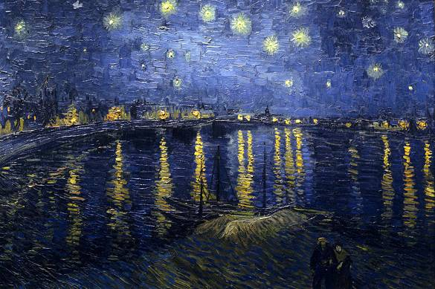
Housing the world's most important collection of impressionist and post-impressionist painting, the Musée d'Orsay's light, airy rooms whir you through three floors of modern wonders, from Degas' ethereal dancers to Monet's water lilies, all the way to Gaugin's leafy jungles. Major works by Van Gogh, Delacroix, Manet, and others await you, too.

11:30am – 12:30p Musée Rodin
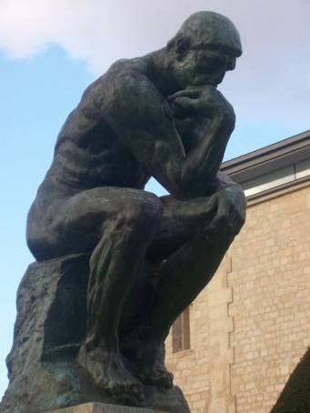
A museum dedicated to the life and work of the great sculptor. The house contains an extensive collection, which is unusually well presented in a spacious building with big windows that are open in nice weather, which makes this museum double pleasant.

1pm – 2pm, Lunch

2:30pm – 3:30pm, Opera De Paris - Palais Garnier
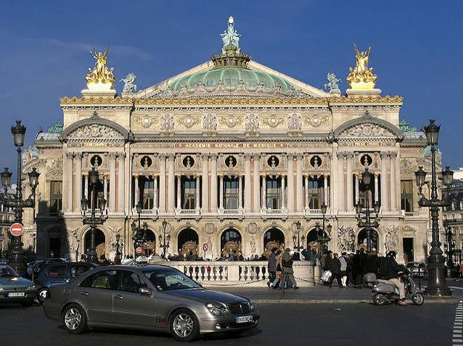
The Palais Garnier is the thirteenth theatre to house the Paris Opera since it was founded by Louis XIV in 1669. A supremely beautiful building, the Paris Opera House was designed by the architect Charles Garnier and built between 1860 and 1875. The most famous and impressive feature of the Palais Garnier is the grand staircase, which must be one of the most opulent staircases in existence. Built from different coloured marble the double staircase leads from the foyer to the auditorium. It adds to the romance and glamour of them to think that this was once the ultimate place for socialites to be seen in all their fashionable glory.
The overall effect of the building is one of stunning extravagance and 18th century decadence. The foyers were designed not simply as foyers but to give the audience somewhere to people-watch and stroll during the interval, they are magnificently decorated with mosaics, mirrors and sculpture.
Don’t miss free guided tour at 2:30pm.

4pm – 5pm, Go to Trocadero metro station
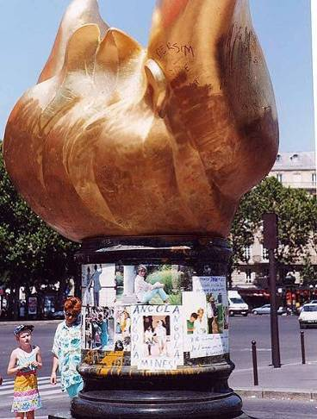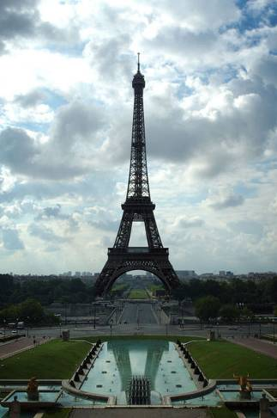
Best view of the Eiffel Tower can be seen from here, so take plenty of photos.
This is also the location of the Statue of Liberty replica and the Flame of Liberty /memorial for Princess Diana. She was killed in the underground tunnel that links Trocadero to the Eiffel Tower.

5pm – 6pm, Ô Château Wine Tasting
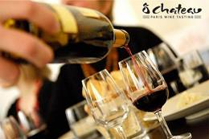
Whether you are a wine novice or a connoisseur, the Ô Château tastings are for you! With a unique approach, focused on fun and pleasure, thanks to your sommelier you will learn a lot, and enjoy the experience.
This wine tasting will teach you all you need to know about French wine. Your English-speaking Ô Château sommelier will introduce you to the pleasures of wine. You’ll learn about basic wine tasting techniques as well as France’s major wine regions. Santé!!!
Wine tasting available at 3-4pm, 4-5pm, 5-6pm only.

7pm – 8pm, Bateaux Parisiens River Cruise
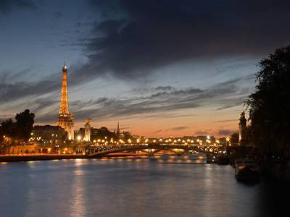
Seeing some of Paris' most beautiful sites glide past as you drift down the Seine river is an unforgettable and essential experience. Dress warmly - the wind from off the Seine can be chilly.
Boat departs every half hour.

8pm – 9pm, Dinner
If we aren’t hungry or if the queue isn’t too long, we might go up the Eiffel Tower first.
9:30pm – 10pm, The Eiffel Tower
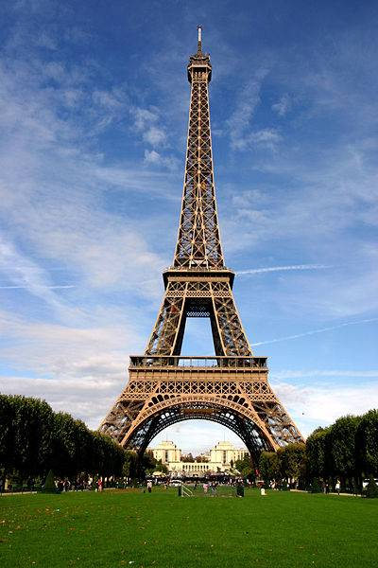
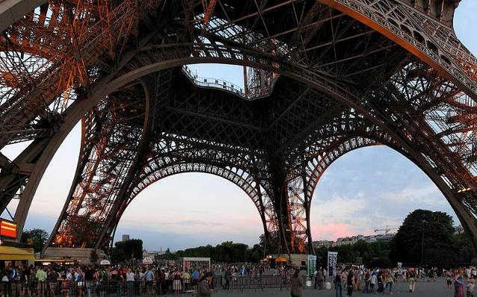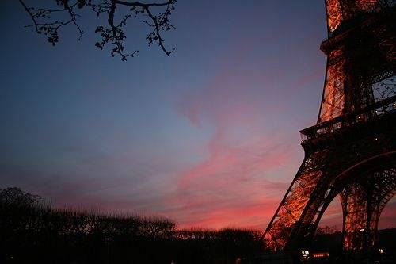
More than any other landmark, the Eiffel Tower has come to represent an elegant and contemporary Paris. The iron tower, which was built for the 1889 World Exposition by Gustave Eiffel, was wildly unpopular with Parisians when it was unveiled, and was nearly torn down. It has since attracted over 220 million visitors, and it would be hard to imagine Paris now without it. The tower crowns the Paris night sky with its festive light, and glitters up a storm every hour. Cliché? Maybe. But essential.

Day Two – Monday, 15 September

9:30am – 10:45am, Notre Dame de Paris Cathedral
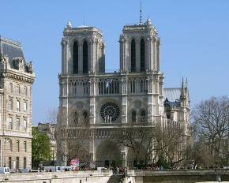
No first trip to Paris is complete without a visit to this marvel of gothic architecture. One of the most singular and beautiful cathedrals of Europe, Notre Dame Cathedral's dramatic towers, spire, stained glass and statuary are guaranteed to take your breath away. Witness firsthand the spot that was once the heartbeat of medieval Paris, and that took over 100 years of hard labor to complete. Climbing the North tower to see Paris from the hunchback Quasimodo's vantage is essential, too. You'll soon understand why Notre Dame is one of Paris' top attractions.

11am – 12pm, Sainte-Chapelle Cathedral
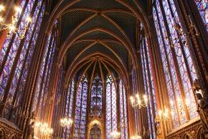
It’s walking distance from Notre Dame.
Far more beautiful than the famous, but gloomy, Notre Dame. The highlight of this small chapel in Rayonnante Gothic style are the large stained-glass windows which soar up to near the vaulted ceiling. Also of interest is the extremely ornate lower level. If it happens to be rainy or cloudy, give Sainte Chappelle a miss, as the play of colored lights on the floor are well worth the wait for a sunnier day.

12:30pm – 1:30pm, Musée national Picasso
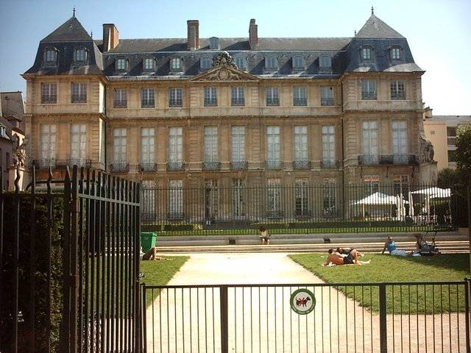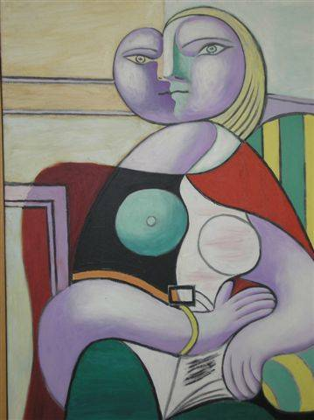
Picasso: the most important and influential artist of the 20th century. The Picasso museum is a journey through the life of this great figure.

2pm – 3pm, Lunch around the area
The area around Picasso Museum is littered with very nice cafés that local Parisiens go to.

3pm – 5:30pm, Musée du Louvre
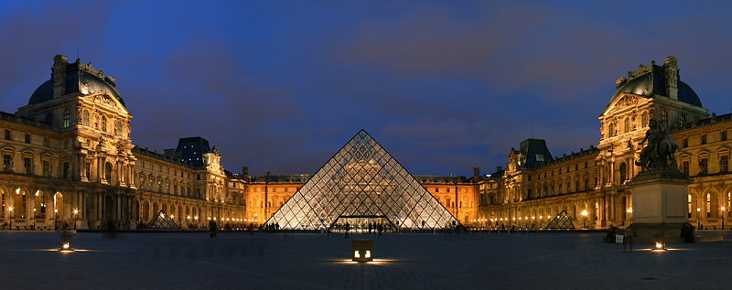
To learn the Louvre in and out, you might need a lifetime. Still, one has to start somewhere. The site of the world's largest and most diverse collection of pre-20th century painting, sculpture, and decorative objects, The Louvre is definitely one of Paris' best attractions. Not forgetting the Mona Lisa and the Venus de Milo, bask in the works of Vermeer, Caravaggio, Rembrandt, and countless other masters. The palace itself is testament to a rich history spanning from the medieval period to the present.

6pm – 7pm, Photo Opportunities around Louvre

7:00pm – 8:00pm, Arc de Triomphe
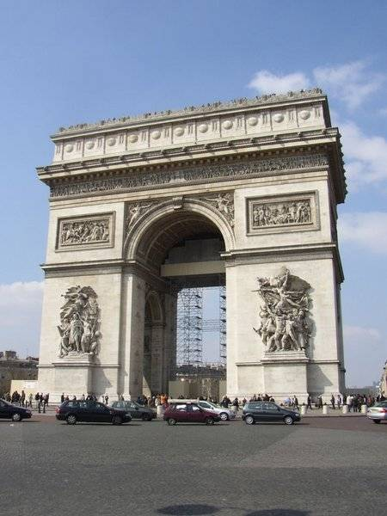
The 164-foot Arc de Triomphe commissioned by Emperor Napoléon I does exactly what it was made to do: evoke sheer military power and triumph. It was built in an age when leaders erected monuments in their own honor, and scaled to their egos. The arch's beautiful sculptures and reliefs commemorate Napoléon's generals and soldiers. Visit the Arc de Triomphe to begin or culminate a walk down the equally grandiose Avenue des Champs-Elysées. You can't help but feel grand yourself.
Come before 8pm for sunset

8pm – 9pm, Tour Montparnasse
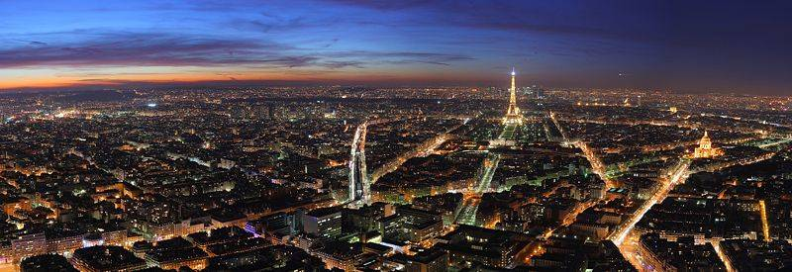
The Tour Maine-Montparnasse towers over all of Paris. It is said that the view from the top is the most beautiful in all of Paris. The view from the top is astounding and on a clear day it is possible to see 40 km in all directions, something even the Sun King couldn’t do.

Day Three – Tuesday, 16 September

Chateau de Versailles
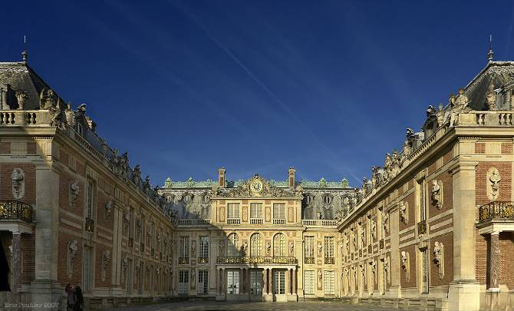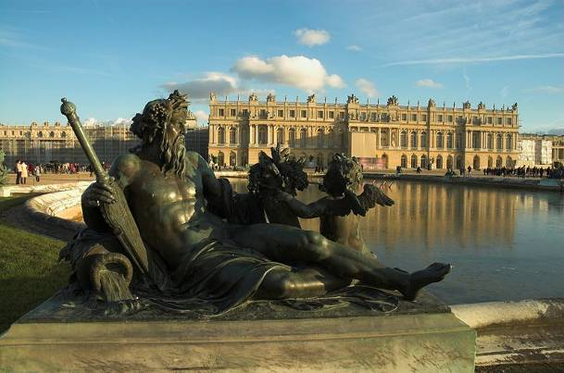
A UNESCO World Heritage Site. Entrance 11 Euros.
The Châteaux de Versailles, also known as the Palace of Versailles, is one of the largest and most opulent castles in the world. Boasting around 2,143 windows, 1,252 fireplaces, and 67 staircases, the Versailles Castle is one of the most visited attractions in France. It is easy to picture kings, queens, czars and dukes strolling through these delightful grounds and perhaps destroying an entire village in order to partake of a light meal. Don't miss the opportunity to visit Versailles on your Paris sightseeing visit - it is truly an amazing place.
Versailles is located 40 minutes by train outside of Paris.

La Grande Arche
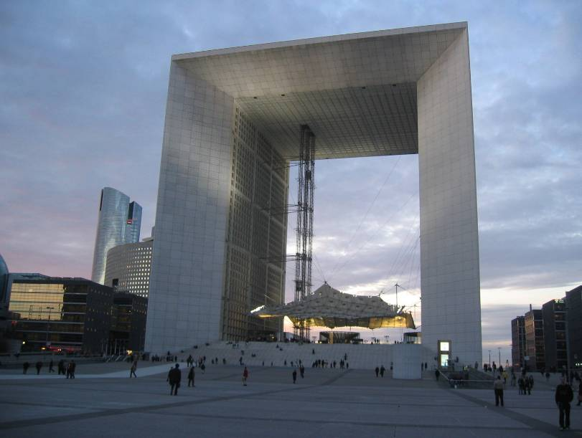
The Grande Arche de la Defense, a high-rise building that reminds more of a hollow cube than an arch per se, has a viewing platform on its top. Entrance fee is € 7.50; this does include the varying small art exhibitions of more or less unknown artists on the upper floor as a "bonus". Definitely recommended for the view. Lines tend to be short. Lunch around here, the business district of Paris.

Shopping At Champs Elysees and Galeries LaFayette
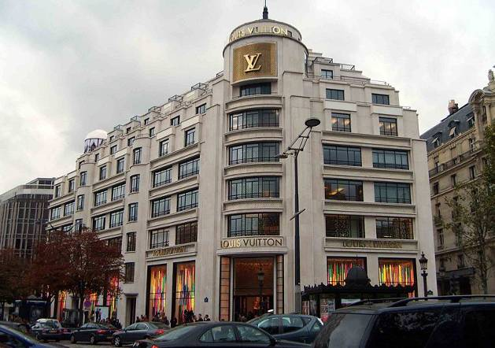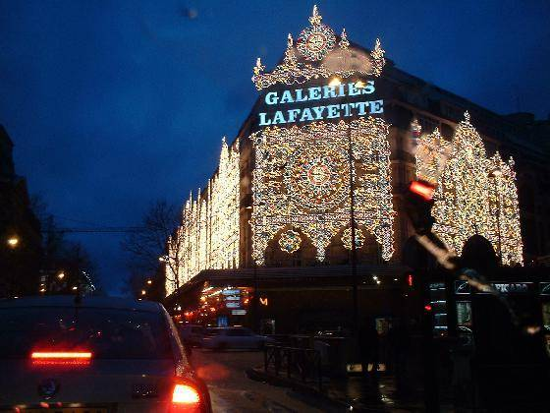
Galeries Lafayette is a humungous 10-storey department store selling everything under the sun. Champs Elysees is the Orchard Road of Paris where all the action is. Be sure to check out Buddha Bar and Hotel Costes after the shops close at 7:30pm.

Montemarte and Basilica of the Sacré Cœur
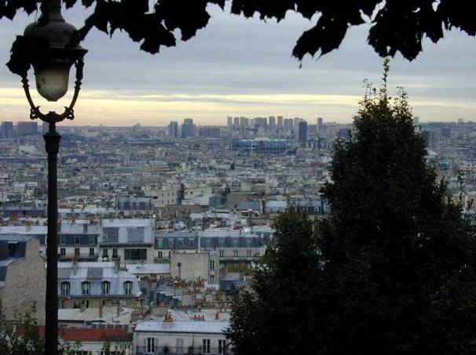
With its unmistakeable white dome, the Sacre Coeur sits at the highest point of Paris on the Montmartre knoll, or butte. This basilica, which was consecrated in 1909, is best-known for its garish gold mosaic interiors and for its dramatic terrace, from which you can expect sweeping views of Paris on a clear day. Take the funicular up with a metro ticket and stop off at Sacre Coeur before exploring the winding, village-like streets of Montmartre. And after expending all your energy climbing Montmartre's formidable hills and stairs, consider a traditional Parisian cabaret at the legendary Moulin Rouge.

Day Four – Wednesday, 17 September
Play it free and easy. Either cram in more sights, or just walk around the neighbourhood to soak in as much French as possible before leaving.
Buy your French cheese, French champagne, French beans and French fries before leaving.

Opening Hours

Attractions closed on Mondays
- Musee d’Orsay, 9:30am – 6pm
- Musee Rodin, 9:30am – 5:45pm (Park till 6:30pm)
- Chateau Versailles, 9am – 6pm

Attractions closed on Tuesdays
- Musee Louvre, 9am – 6pm
- Musee Picasso, 9:30am – 6pm
- L’Orangerie, 9am – 6pm

Attractions opening daily
- Arc de Triumphe, 10am - 11pm
- La Grande Arche, 10am – 8pm
- Notre Dame, 10am – 6:30pm (no advanced access)
- Saint Chapelle, 9:30am – 6pm
- Basilica of the Sacré Cœur, 6am – 11pm
- Tour Montparnasse, 9:30am – 11:30pm
- Eiffel Tower, 9:30am – 11:45pm (no Paris Pass, final lift up at 10:30pm)
- O Chateau Wine Tasting, 3pm, 4pm and 5pm
- The Pantheon, 10am – 6:30pm
- Moulin Rouge, 9pm and 11pm (no Paris Pass, 99 Euro with bottle of champagne)
- Palais Garnier Opera House, 10am – 5pm (guided tour 11:30am & 2:30pm Sunday only)
- Seine River Cruise, every 30mins 10am – 10:30pm

